**Individual Project 1:**

**Location Analysis for Corporate Client**

***Please submit your report in Word to*** [***freybote@pdx.edu***](mailto:freybote@pdx.edu) ***on or before 11/12/2024 at 11.59pm.***

***Please make sure the respective Word and Excel files have your name on it! Points will be deducted if your name is missing.***

**BACKGROUND**

You are a consultant for Healthy Paws, an animal hospital founded by Charly McDonnell and JC Smith in 2011. The clinic focuses primarily on dogs, cats, and smaller pets (e.g., bunnies). They do not provide services for livestock and large animals. They focus on general practice, as opposed to specialty or referral services, and do not offer after hours emergency services. They also don’t provide boarding, daycare, or grooming services.

Healthy Paws aims at providing affordable pet care while creating a family-like environment in their clinic to reduce stress to patients and their owners as well as fostering education and responsible pet ownership. Their mission is as follows:

“*At Healthy Paws, our mission is to provide compassionate and comprehensive veterinary care to enhance the health and well-being of every furry friend entrusted to our care. We are dedicated to fostering the human-animal bond by delivering high-quality medical services, personalized attention, and education to pet owners. Our commitment extends beyond treating illnesses; we strive to promote preventive care, responsible pet ownership, and a supportive environment that values the unique needs of each animal. Paws & Whiskers Animal Clinic is not just a healthcare provider for pets; it is a haven where love, expertise, and empathy converge to create a healthier and happier world for our beloved animal companions*.”

Healthy Paws opened their first animal hospital in Seattle, WA in 2011. The location of the first office in a retail property was chosen without a particular strategy, but JC insisted on selecting a building with character. Fortunately, the first location turned out to be ideal for the clinic. The owners of the firm would like to expand into the Portland market and rent space for a new vet clinic.

They plan on having two veterinarians and three examination rooms that should be a minimum of 1,000 SF per room. The target size for their new office is between 3,500 and 5,000 SF. They would like to lease retail space for their new clinic and will negotiate with landlords on capital improvements once properties have been identified.

Happy Paws has the following requirements for the location of their new clinic:

**Must Haves**

* Good visibility, ideally a corner lot and close to intersections/roads with high traffic counts.
* Good accessibility in terms of getting in and out of the clinic.
* Sufficient parking close to the clinic, especially for emergencies.
* A primary trade area with a population base of 8,000 to 10,000.
* Commercial zoning (*Note: For this assignment, you do not need to further investigate zoning regulations, deed covenants or utilities*)
* Space that is open plan or have as little internal load bearing obstructions.
* Single-story space on ground-level, i.e., the floor size needs to accommodate at least 3,500 SF.
* Class A or B.
* Safe area for staff and patients.
* Rent of $22 to $25 per SF, any lease type (e.g., NNN, net, gross).

**Nice to Have**

* Building with character/architectural interest.
* Mix of businesses close by that might draw pet owners and increase visibility.
* Outside space for pets to use (e.g., fenced enclosure or greenspace).
* Adjacent businesses that are less likely to be concerned with pet noises.
* Access to public transportation.

**YOUR TASKS**

1. Identify three demand drivers for pet clinic services that will be used to analyze different locations in ArcGIS. Explain in your report why you selected these three drivers.

To analyze potential locations for Healthy Paws’ new clinic in Portland, three key demand drivers for pet clinic services have been identified:

1. **Pet Ownership Rates**

* **Rationale:** The increasing number of pet owners directly correlates with the demand for veterinary services. As of 2023, approximately 70% of U.S. households own pets, and this trend is expected to continue growing. Higher pet ownership leads to increased visits to veterinary clinics for routine check-ups, vaccinations, and emergency care.
* **Impact:** A location with a higher concentration of pet owners will likely yield more clients for Healthy Paws.

2. **Disposable Income Levels**

* **Rationale:** Economic factors significantly influence spending on pet care. Households with higher disposable incomes are more likely to spend on preventive care, routine visits, and emergency services for their pets. The veterinary services market is projected to grow alongside increases in consumer spending on pets.
* **Impact:** Areas with higher average incomes will likely support Healthy Paws’ mission of providing affordable yet high-quality care, as residents may prioritize pet health expenditures.

3. **Population Density and Demographics**

* **Rationale:** A primary trade area with a population base of 8,000 to 10,000 is essential for sustaining a successful clinic. Additionally, demographic factors such as age and family structure can influence pet ownership trends. Younger families and individuals are often more inclined to own pets and seek veterinary care.
* **Impact:** Locations with a suitable demographic profile will provide a steady stream of clients who value the compassionate care that Healthy Paws aims to offer.

Summary

Incorporating these demand drivers into location analysis using ArcGIS will help Healthy Paws identify optimal sites for their new clinic in Portland. By focusing on areas with high pet ownership rates, disposable income levels, and favorable demographics, the clinic can enhance its chances of success in the new market.

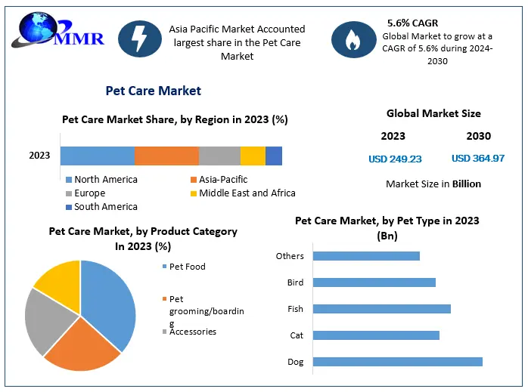

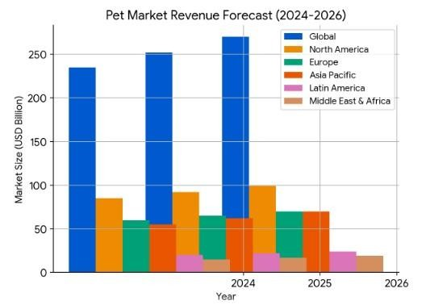

1. Download the *Project 1_Dataset* file from Canvas. This is a dataset downloaded from Costar with all retail properties with current vacancies in the Portland MSA.
2. In this dataset, delete any spaces currently for rent from the Excel file that don’t meet the clinics requirements in terms of vacant space available and minimum floor size. Remove any secondary types that are inappropriate for a vet clinic such as restaurant, bank, or auto repair. Your client is not interested in making such large changes to the space. They also only want to consider properties with signs/signage as amenities. The clients also do not want to be in a property that is currently for sale to eliminate any landlord-change related complications.
3. Log into ArcGIS Business Analyst, create a new project and upload your Costar datafile. Make sure each property is represented by a single point.
4. Use the Smart Map function (use census blocks as level of detail).
   1. Select three variables from the available variables that match your demand drivers identified in 1) the most. Provide information on the ranges for variables you selected.
   2. Additionally select one Tapestry household group that matches what you think the clinic’s target client is. Discuss why you selected this Tapestry group as the clinic’s primary demographic.
   3. Copy your final map into your report. How many properties in your sample fall into highlighted locations?
5. Select two properties from your ArcGIS analysis to further investigate. These properties should be in different submarkets. Your selection can be based on any of the client’s criteria, your familiarity with a neighborhood, etc.
6. For each of these two properties, what do you consider the trade area? Roughly explain the trade area for each property with regards to physical and other barriers (e.g., major roads, river, hills) and discuss why you consider them appropriate.
7. For those two properties, analyze the following and provide your answers in the report:
   1. Strength & Weaknesses: Prepare an overview of the strengths and weaknesses of each of the properties/sites with regards to the client’s requirements.
   2. Competitors: How many, if any pet clinics/vets are in the same neighborhood that might be direct competitors? If available, investigate the clinics’ websites to determine if they provide comparable services to Happy Paws.
   3. Complementary Uses: Are there any uses close by that could be beneficial to the clinic in terms of drawing attention from pet owners?
   4. Nuisance: Are there any uses close by that either represent a nuisance to the clinic or would consider the clinic to be negative for their business?

*If you do not have access to Costar, but want more information about each property (e.g., photos), please let me know. You can conduct the analysis in 7) without Costar information, e.g., by using Google.*

1. Go into Costar Analytics *(MSRE students)* or the Costar retail market reporton Canvas *(other students)* to assess whether the asking rent for each property is appropriate for submarket and Costar rating. Are the two spaces appropriately priced? If not, which is mispriced and what could explain it?
2. Following your analysis, which property do you recommend the client to focus on first as it’s the preferred option? Explain why.

**DELIVERABLE**

Prepare a report for your client that presents the results of your analysis, your discussion and final recommendation. Your report should have the below structure and have at least 10 pages (font: 12, spacing: 2pt), including executive summary (1 page), tables, pictures, and graphs.

**Individual Project 1_DaoDang:**

**Location Analysis for Corporate Client**

**Executive summary:**

This report evaluates two potential locations for establishing a pet clinic: the Lloyd District submarket and the Sunset Corridor/Hillsboro submarket. After using ArcGIS to analyze demand drivers and key factors such as market conditions, demographics, community, and competitive landscape, comparing the Costar retail market report, it is recommended that the client focus on the Lloyd District submarket as the preferred option for the clinic.

The Lloyd district is expected to attract a growing population of young professionals and families. Its high visibility, accessibility via public transportation, and proximity to major attractions provide an advantageous setting for a pet clinic. Furthermore, the area hosts various community events that can facilitate engagement with potential clients. In contrast, while the Sunset Corridor boasts an affluent demographic and proximity to high-tech firms with more green space, it faces challenges such as higher asking rent, increased competition from established veterinary practices, and declining growth trends. Therefore, the Lloyd District submarket presents a more promising opportunity for establishing a successful pet clinic in the long term.

**Introduction:**

As a consultant for Healthy Paws, in this project, the potential retail locations for the pet clinic’s expansion into Portland, Oregon, will need to be identified and evaluated based on several requirements. The project aims to identify and secure a suitable retail space that aligns with the clinic’s mission of providing affordable pet care, focusing primarily on dogs, cats, and smaller pets, not providing boarding, daycare, or grooming services. Key objectives include locating properties that meet specific requirements, negotiating favorable lease terms, and designing an efficient clinic layout. The new location must meet several essential criteria, including high visibility on a corner lot near busy intersections, easy accessibility, adequate parking, and a primary trade area with a population of 8,000 to 10,000. The property should be commercially zoned, single-story with an open plan design, and between 3,500 and 5,000 square feet in size. Additionally, it should be situated in a safe area with rent ranging from $22 to $25 per square foot.

To execute the project, market research will be conducted to identify suitable neighborhoods and properties by using ArcGIS. Moreover, engaging landlords for lease negotiations by Costar will be crucial, along with collaborating with designers to create a functional clinic layout. After locating ideal places, the next step is to evaluate each based on how well they align with Healthy Paws’ mission and operational needs and provide a final recommendation of the top properties for the new clinic. This report includes detailed assessments and a rationale for recommendations, along with considerations on lease terms and potential tenant improvements.

**Discussion of analysis and results:**

To analyze different locations for a pet clinic using ArcGIS, three potential key demand drivers will need to be focused on: pet ownership rates, disposable income levels, and population density and demographics. These factors are very essential in identifying areas with the highest potential for clinic services.

As of 2024, over 50% of Oregon households own at least one pet[1] , and this trend is expected to continue growing. Higher per ownership leads to increased visits to veterinary clinics for routine check-ups, vaccinations, and emergency care. A location with a higher concentration of pet owners will likely yield more clients for Healthy Paws. Besides that, households with higher disposable incomes are more likely to spend on pet services. In addition, Locations with a suitable demographic profile will provide a steady stream of clients who value the compassionate care that Healthy Paws aims to offer. Age and family structure can influence pet ownership trends. Younger families and individuals are often more inclined to own pets and seek veterinary care. Incorporating these demand drivers into location analysis using ArcGIS will help Healthy Paws identify optimal sites for their new clinic in Portland. By focusing on areas with high pet ownership rates, disposable income levels, and favorable demographics, the clinic can enhance its chances of success in the new market.

To meet the project requirements and refine *Project 1_Dataset,* we focused on identifying vacant spaces that meet the minimum floor size criteria, eliminating any secondary property types that are not suitable for a veterinary clinic, such as restaurants, banks, and auto repair shops. Additionally, we considered properties with signage as a valuable amenity and avoided those currently for sale to prevent complications related to landlord changes. This process resulted in the identification of 14 properties for analysis in ArcGIS. Utilizing the Smart Map function, we employed census blocks as the level of detail and selected three relevant variables from the available options that align with our identified demand drivers. Below is the result map that we got from ArcGIS Business Analyst on the ranges for variables:

* 2024 HH Owns Any Pet(%): 39.98% - 61.38%

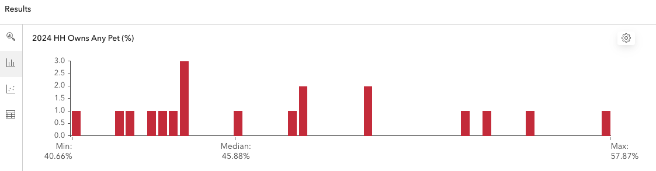

* 2024 Median Disposable Income: $70,340 - $159,687

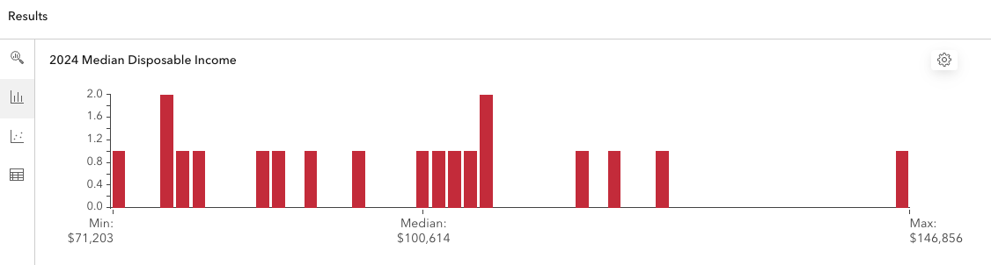

* 2024 Population Density: 8,030 to 10,023

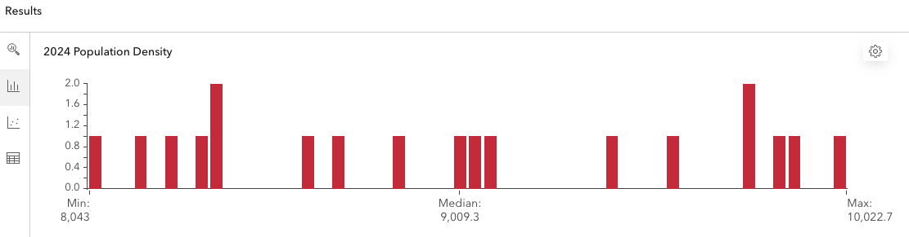

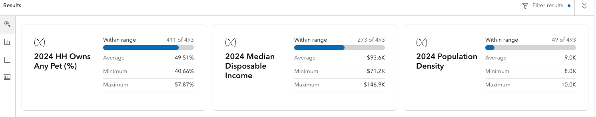

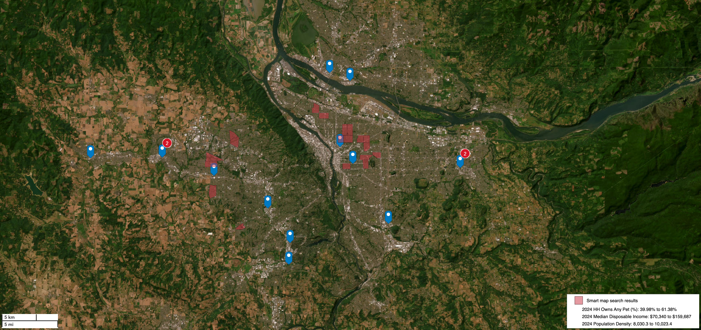

ArcGIS Business Analyst Map

From ArcGIS analysis to further investigate different submarkets, the selection of properties for a pet clinic are feature 9 and 10. These properties in the Lloyd District (feature 9) and Sunset Corridor/Hillsboro (feature 10) are strategically advantageous due to several key factors:

* Accessibility: both locations are conveniently situated near major highways and roads, making them easily accessible for clients (Interstate 84, and US-26). This is crucial for pet owners who may need urgent care or regular veterinary services.
* Parking facilities: Each property features two large parking lots, which not only accommodate clients but also enhance the overall convenience of visiting the clinic.
* Demographics: The target areas boast a population exceeding 8,000 residents, with an average income of over $100,000. This demographic is likely to invest in quality pet care, as they typically have a higher percentage of pet ownership.

**Lloyd District Insights (Feature 9: 1407 NE Halsey St, Portland, OR 97232-1475)**

* Urban Development: The Lloyd District is undergoing significant residential development, including plans for public spaces and pedestrian walkways. This will create an environment conducive to pet walking and increase foot traffic around the clinic, attracting more clients.
* Attraction and Transportation: The area serves as a gateway to major Portland attractions and is well-connected by public transport, including the Max light rail. This accessibility can draw in clients from surrounding neighborhoods[2]
* Future Growth: As the district evolves into a mixed-use area with shopping and dining options, it is poised to attract a younger demographic of residents who are likely to own pets, thus expanding the potential client base for the clinic.

**Sunset Corridor/Hillsboro Insights (feature 10: 20225-20285 SW Tualatin Valley Hwy, Beaverton, OR 97006):**

* Tech Hub: The Sunset Corridor is home to a concentration of high-tech firms such as Intel and Tektronix, Columbia, Nike, etc. This economic activity supports a community with disposable income that values quality pet care.
* Proximity to Amenities: The area’s proximity to shopping centers and public transportation (many Tri-Met Max light rail accessible), many shopping around Cedar Hills, Aloha, Rock Creek, and Oregon Station enhances its appeal as a residential location, making it ideal for establishing a pet clinic that caters to busy professionals [3].

Therefore, both selected properties not only meet logistical requirements but also align with demographic trends that favor pet ownership and investment in veterinary services. The strategic positioning within these vibrant neighborhoods will likely foster growth and sustainability for the proposed pet clinic.

When analyzing more potential impact of nearby businesses on a proposed pet clinic in Lloyd District (Feature 9) and Sunset Corridor (Feature 10), it is essential to consider various factors, including strengths, weaknesses, competitors, complementary uses, and potential nuisances.

|  |  |  |
| --- | --- | --- |
|  | Feature 9 _ Lloyd District | Feature 10_Sunset Corridor |
| Strengths | High Foot Traffic: the presence of major venues: Oregon Convention Center, Moda Center attracts significant foot traffic, which can benefit a pet clinic through increased visibility and client acquisition.  Host several community events provide potential benefits for clinic: visibility and engagement, educational opportunities can educate pet owners on health issues, care, services, and networking with local businesses (create cross promotional opportunities)  Urban Revitalization: Ongoing redevelopment plans to create a vibrant mixed use neighborhood, enhancing the appeal for pet owners who value accessible services. | High Income Demographic: The presence of high-tech firms contributes to a wealthier population likely to invest in premium pet care services.  Family-Oriented Community: The suburban feel and family-oriented amenities attract residents who are more likely to own pets. |
| Weaknesses | Limited Residential Space: more commercial properties and hotels than residents units, which may limit the local pet-owning population  Potential Noise: Proximity to entertainment venues could lead to noise disturbances that might be stressful for pets | Less Urban Density: has lower urban density, which might result in fewer spontaneous visits from potential clients. |
| Competitors | There are several existing competitors veterinary Clinics nearby: Pet Samaritan Clinic, BluePearl Pet Hospital, Heartfelt Veterinary Hospital, etc. | Similar to Lloyd District, there are existing veterinary clinics and pet supply stores: Cedar Mill Veterinary Hospital, Northwest Exotic Pet Vet, Bethany Family Pet Clinic, etc. |
| Complementary Uses | Pet-friendly Businesses: nearby parks and pet friendly cafes  Retail and Dinning options: The mix of retail and dining establishments can enhance clients’ experiences, encouraging them to visit the clinic as part of outing. | Parks and recreational Areas: this location has more greenspaces of larger parks encourages pet ownership and can drive traffic to a nearby clinic.  Community Events: Local events or markets can draw families with pets, increasing potential interactions. |
| Nuisance Factors | Substance Abuse Services: Nearby facilities Central City Concern provide services for who are impacted by homelessness, poverty and addiction. While they serve an important community need, their presence might deter some clients due to concerns safety or discomfort around vulnerable populations. | Industry Areas: could produce noise or odors detrimental to a pet clinic’s environment.  Traffic Congestion: Heavy traffic due to commuting workers could create accessibility issues for clients trying to reach the clinic during the peak time. |

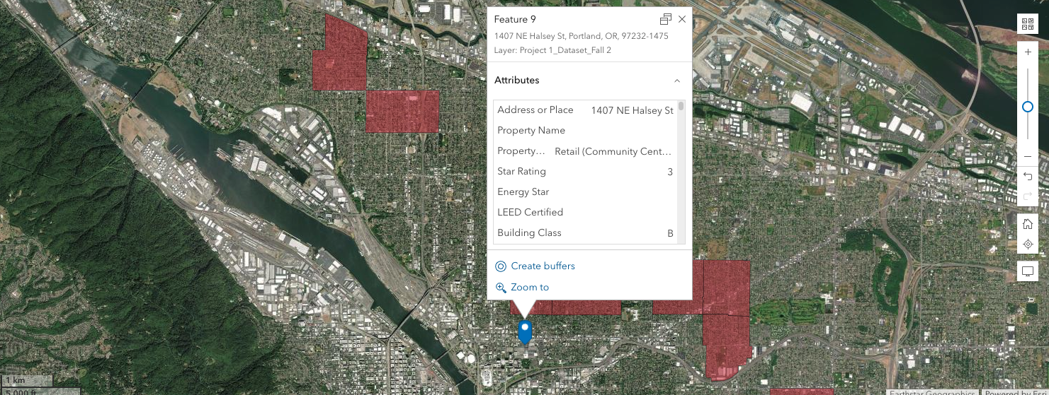

ArcGIS Business Analyst _ Feature 9

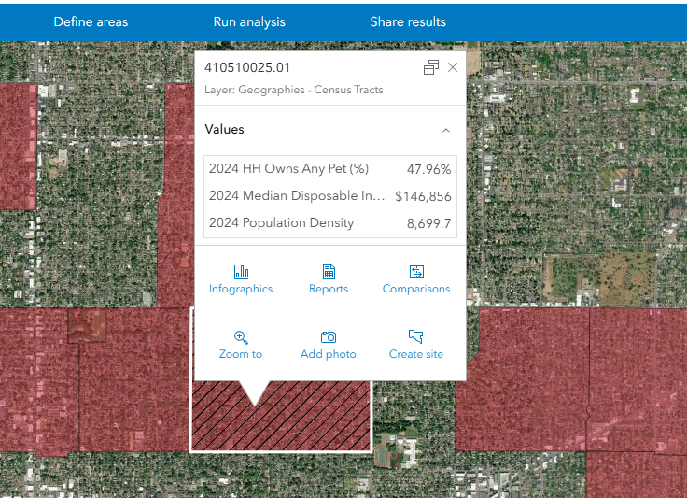

Lloyd District Neighborhood

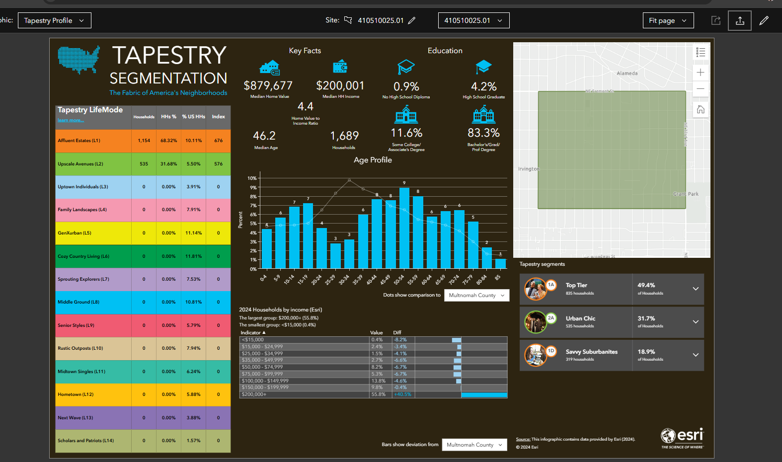

Tapestry of Lloyd District Neighborhood

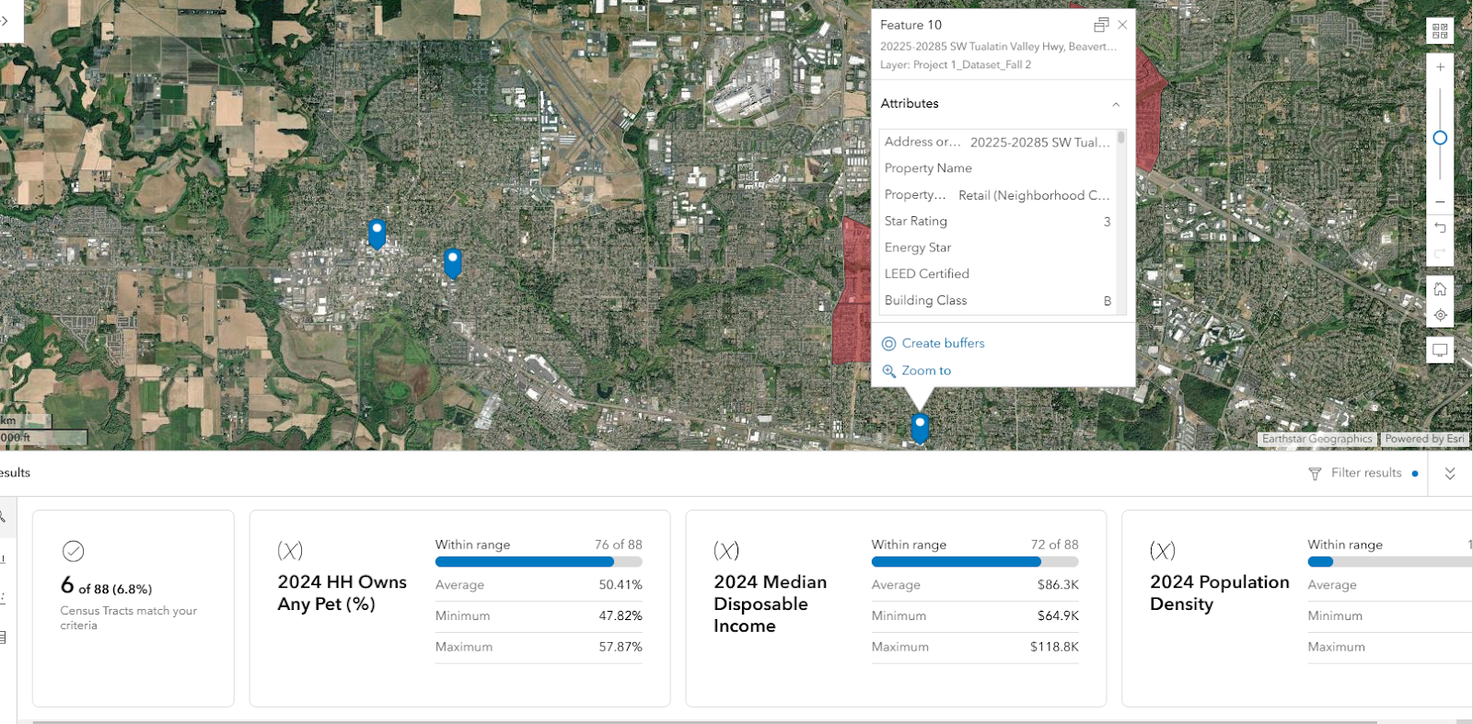

ArcGIS Business Analyst _ Feature 10

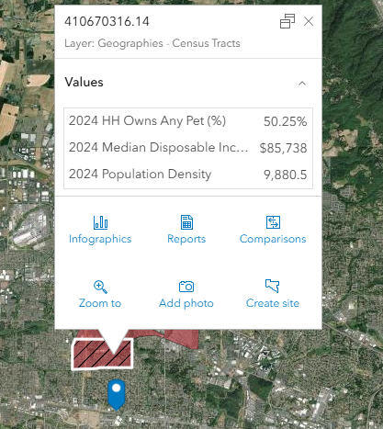

Sunset Corridor/ Hillsboro Neighborhood

Based on statistics from the Costar Retail Market Report, feature 9 with Lloyd District’s asking rent of $24.65 is lower than feature 10 with Sunset Corridor’s $27.85, indicating that Lloyd District may offer a more cost-effective option for tenants. Moreover, both areas show negative growth rates, with Lloyd District at -0.7% and Sunset Corridor at -0.6%. This suggests a slight decline in demand or pricing power in both submarkets. Also, the QTD annualized changes are also negative, with Lloyd District at -1.6% and Sunset Corridor at -2.4%, indicating a more pronounced decline in the Sunset Corridor.

Given this information, while both spaces are experiencing negative growth, the Lloyd District appears to be appropriately priced, given its lower asking rent and potential for future development and revitalization. This could attract more foot traffic and potentially increase demand in the future. The Sunset Corridor, despite its higher asking rent due to high-tech firms and family-oriented amenities, may be mispriced considering its declining growth rates and recent market trends indicating a tougher competitive landscape.

**Managerial recommendation:**

Based on the analysis, I recommend client focus first on feature 9 with the submarket Lloyd District for establishing a pet clinic. The reason is the Lloyd District is undergoing significant urban redevelopment, which includes plans for more residential spaces and pedestrian-friendly areas. This will attract more younger demographic and increase foot traffic. Moreover, this location has major attractions: Oregon Convention Center and various shopping venues provides high visibility for a new clinic. Its excellent public transportation options: Max Light access, and enhanced accessibility for pet owners from surrounding neighborhoods. Lloyd District also hosts various community events that can attract pet owners, providing opportunities for the clinic to engage with potential clients.

Focusing on the Lloyd District presents a compelling opportunity for establishing a pet clinic due to its growth potential, visibility, community engagement possibilities, evolving demographics, and lower asking rate. While challenges exist in terms of competition and safety perceptions, particularly near Holladay Park, these can be addressed through careful planning and strategic marketing efforts such as choosing a site away from these trouble spots can mitigate risks. The area’s revitalization efforts make it an ideal position for long-term success in the veterinary market.

Identify three demand drivers for pet clinic services that will be used to analyze different locations in ArcGIS.

To analyze potential locations for Healthy Paws’ new clinic in Portland, three key demand drivers for pet clinic services have been identified:

1. **Pet Ownership Rates**

* **Rationale:** The increasing number of pet owners directly correlates with the demand for veterinary services. As of 2023, approximately 70% of U.S. households own pets, and this trend is expected to continue growing. Higher pet ownership leads to increased visits to veterinary clinics for routine check-ups, vaccinations, and emergency care.
* **Impact:** A location with a higher concentration of pet owners will likely yield more clients for Healthy Paws.

2. **Disposable Income Levels**

* **Rationale:** Economic factors significantly influence spending on pet care. Households with higher disposable incomes are more likely to spend on preventive care, routine visits, and emergency services for their pets. The veterinary services market is projected to grow alongside increases in consumer spending on pets.
* **Impact:** Areas with higher average incomes will likely support Healthy Paws’ mission of providing affordable yet high-quality care, as residents may prioritize pet health expenditures.

3. **Population Density and Demographics**

* **Rationale:** A primary trade area with a population base of 8,000 to 10,000 is essential for sustaining a successful clinic. Additionally, demographic factors such as age and family structure can influence pet ownership trends. Younger families and individuals are often more inclined to own pets and seek veterinary care.
* **Impact:** Locations with a suitable demographic profile will provide a steady stream of clients who value the compassionate care that Healthy Paws aims to offer.

Summary

Incorporating these demand drivers into location analysis using ArcGIS will help Healthy Paws identify optimal sites for their new clinic in Portland. By focusing on areas with high pet ownership rates, disposable income levels, and favorable demographics, the clinic can enhance its chances of success in the new market.

Your report should include an executive summary at the beginning (bullet points are ok), a discussion of the results of your analyses and your recommendations. ***The executive summary is not an introduction section!*** For more information on how to write an executive summary, please visit: https://writingcenter.uagc.edu/writing-executive-summary

When presenting and discussing your results, keep the requirements of the client in mind to help you structure your argumentation and presentation of results. I recommend using a brief overview of the client’s requirements in your introduction. After all, you are using the analysis to try to identify the best location for their next pet clinic.

Make sure your report is reader-friendly, professionally written, and free of typos and grammatical errors. Assume this is a report you submit to your client. If you want, you can even create a firm name and/or logo for yourself. Make sure to add page numbers.

1. https://www.thezebra.com/resources/research/pet-ownership-statistics/
2. https://www.travelportland.com/meetings/new-in-lloyd-neighborhood/
3. https://www.eleeterealestate.com/blog/neighborhoods/sunset-corridor-2